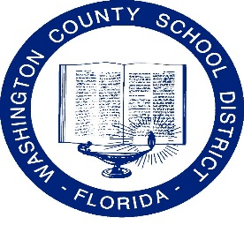
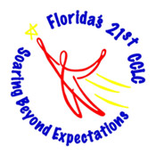
Washington County School District
21st Century Community Learning Centers
Soaring to the Future Program

652 Third St
Chipley FL 32428
850-638-6222

To: Soaring to the Future Enrichment Program Parent(s)
This letter is to notify you that we will begin bus transportation to certain areas within or close to your community for students enrolled in the Soaring to the Future Enrichment Program. The following bus stops will be provided for your student(s), Please mark the bus stop that will benefit or assist you in picking up your student(s).

We ask that you please be at the bus stop on time, since drivers will need to move on to other stops on the route. The bus will run Monday-Friday, loading and leaving the school at approximately 6:00 PM.

Student Name: ______________________________________

Parent Name: ________________________________________

_______ Route 1
- Sunny Hills/Greenhead Driver-Mrs. Judy Dybdal Bus #07-13
Approx. Time of Arrival 6:10-6:15 Rainbow Store
6:20:6:25 Sunny Hills Entrance
6:30-6:35 Tom Thumb

_______ Route 2
- Caryville Driver-Mrs. Vera Truett Bus # 12-27
Approx. Time of Arrival 6:18-6:20 New Hope Store
6:30-6:35 5-Points
6:35-6:45 Caryville City Hall

The staff of the Soaring to the Future Enrichment Program thank you for your assistance in this matter. If you have any issues, please contact Mrs. Cindy Richards (Site Coordinator) at Vernon Elementary School or Mrs. Michele Carter (Project Coordinator) at Vernon High School.

