Vernon Elementary School

Steve Griffin

Principal

Latina English
Assistant
Principal
3665 Roche Avenue
Vernon, Florida 32462
Phone (850)535-2486 Fax (850)535-1437
Website: http://ves.wcsdschools.com

Academic Excellence Is Our Ultimate Goal!!!

VES Mission: Vernon Elementary School is committed to personal and academic excellence for all students.
VES Vision: Vernon Elementary School will provide students the highest quality education possible, with the resources necessary, so they can achieve their maximum potential and become knowledgeable, responsible, and competent citizens.

MARCH 8, 2019
IMPORTANT DATES:
March 10 Daylight Savings Time begins / Set Clocks Forward
March 13 Biophilia 4th Grade
March 19 Spring Pictures
March 25-29 Spring Break (No School)
April 5 1st Grade field Trip to Shell Island
April 9 Report Cards goes home
April 11 2nd Grade Field Trip to the Pirate Ship
April 12 5th Grade field Trip to Rockit Lanes

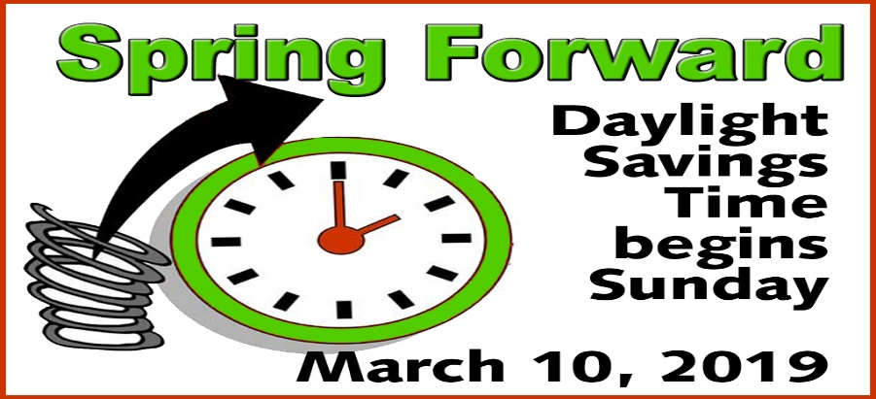

OFFICE NEWS: Parents, please send bus or car riders notes to the following email addresses; Tammy.Coatney@wcsdschools.com; Sandra.Brown@wcsdschools.com; or Brandi.Jackson@wcscdschools.com; Notes will not be taken over the phone and need to be sent by 2:00 pm.

PARENTS: Penny Wars start next week for Relay for Life. Let the challenge begin!

PARENTS: Please contact the school if you have made changes to the following:address, phone number, who can pick up your child, and bus number.

Field Day T-Shirt order forms went home this week. Please note there was an error on the dates, they should have read - Thursday, April 11th, 3rd-5th grades / Friday, April 12th, K/1st/2nd grades. Also, all shirts are pre orders ONLY, due back by March 18th!

City of Vernon Recreation Center is having sign-ups for T-Ball, Softball and Baseball. T-Ball is $25, must be age 4 by 5/1/19; Baseball is $30, must be age 7 by 5/1/19; Softball is $30, must be age 7 by 8/31/19. Registration is at the City Hall. Contact Brent Gibson 850-260-4002 or 850-258-9492.

CLINIC NEWS: Just a reminder that students must be FEVER FREE WITHOUT medication for 24 hours before returning to school. Encourage your child to cover their cough correctly and wash their hands frequently.

Birthday Wishes: March 10th – 16th: Samuel McGinnis, Cullan McLean, Brooklyn Ector, Abbigail Ellis, Cooper Hammack, Lily Stufflestreet, Hunter Ziegler, Shelby Dodson, Carson Claudio, Paris Davis, Kylee Hebble, Owen Blankenship

Yearbook Sales have begun and order forms were sent home with your student. The yearbook is an all color, hardbound book filled with pictures and memories of this school year; February 15th – March 12th, $28. You can also order online at www.inter-state.com/yearbook and enter this code 32602Z.

