NO COST EYE EXAMS AND EYEGLASSES PROGRAM
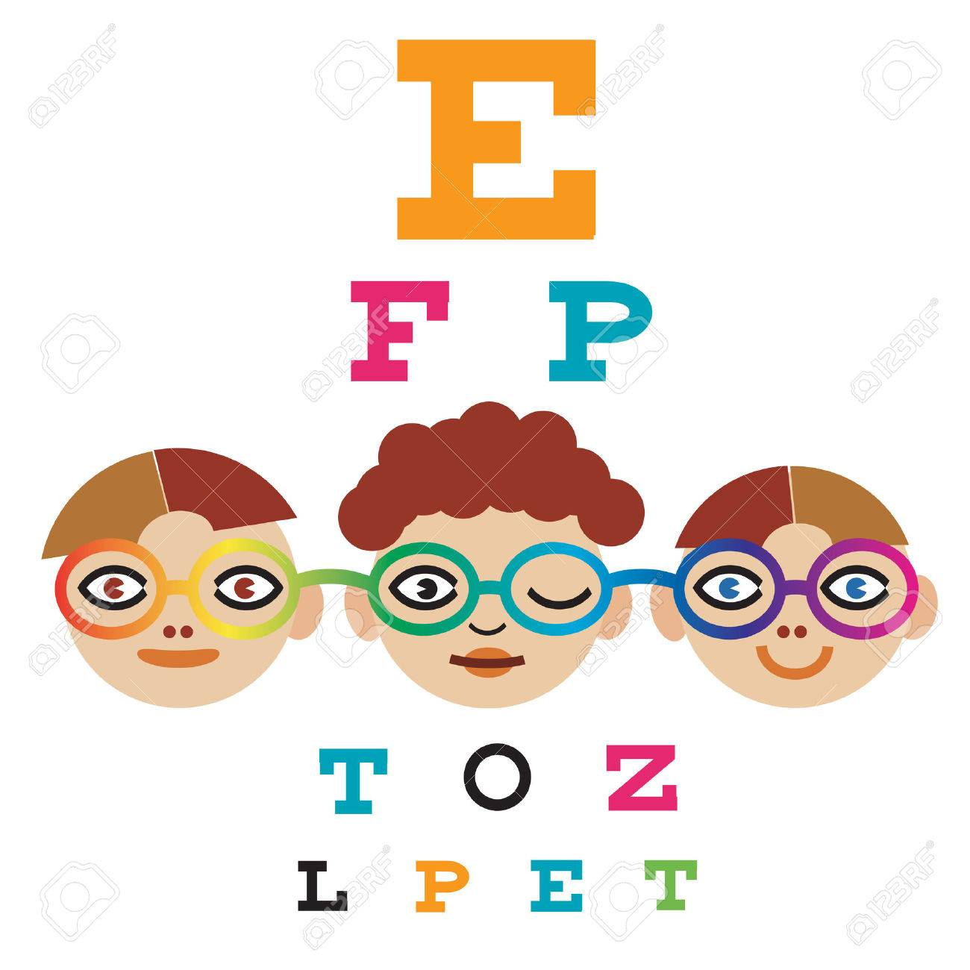
SEE THE OFFICE OR YOUR SCHOOL NURSE FOR THE FORM!

