Orientation: Thursday, August 8th
PK, VPK and Kindergarten 12:00 - 1:00
1st & 2nd 1:00 - 2:00
3rd, 4th, & 5th 2:00 – 3:00

VPK – Backpack has been donated
Kindermat + Blanket (full day students only)
1 Box of Gallon Ziploc Bags
1 Box of Quart Ziploc Bags
1 Pack of Dry Erase Markers (3 pack)
1 Box of Kleenex
1 Container of Disinfecting Wipes

Kindergarten- Backpack has been donated
4 Black Dry Erase Chisel Tip Markers
1 Box of Reg Crayons (24 pk)
2 Jumbo Pencils w/Erasers
1 Watercolors Paint Box
Girls - 1 Box of Tissues
Boys - 1 Clorox Wipes

1st Grade- Backpack has been donated
1 Pkg of Glue Sticks (4 ct)
2 Box of Tissues
2 Folders (w/pockets, no prongs)
4 Boxes of Crayons (24 ct)
2 Containers of Disinfectant Wipes
1 Bottle Hand Sanitizer
Boys- 1 Box Quart Size Zip Bags
Girls- 1 Box Gallon Size Zip Bags
1 Pair of Headphones (no earbuds)-not shared

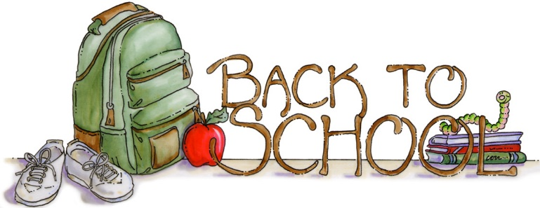

2nd Grade
1 Box of Tissues
2 Box of Crayons (24 ct)
1 Pair Child Size Blunt Scissors
2 Two Pocket Plastic Folders (solid color)
1 Container of Disinfectant Wipes
1 Bottle Hand Sanitizer
2 Packages of Glue Sticks
Girls – 1 Box of Quart Size Ziploc Bags
Boys – 1 Box of Gallon Size Ziploc Bags

3rd Grade
1 Pack #2 Yellow Pencils (24 ct.)
1 Box of Crayons (24 ct)
1 Box of Tissues
4 Marbled Composition Notebooks
1 Pack Black Chisel Tip Dry Erase Markers (3 or more)
1 Pack Variety Chisel Tip Dry Erase Markers
Glue Stick (1pack)
Headphones/Earbuds (will not share)

4th Grade
2 Folders (plastic w/3 prongs)
1 Pack of Chisel Tip Dry Erase Markers
3 Packs #2 Yellow Pencils (24 ct)
1 Pack of Mechanical Pencils
1 Pack of Dividers (8 ct)
1 Mead Composition Notebooks
1 Bottle Hand Sanitizer
Boys - 1 Box Gallon Size Ziploc Bags
Girls - 1 Box Quart Size Ziploc Bags
1 Pair of Headphones/Earbuds -not shared

5th Grade
1 Pack of #2 Pencils (24 ct)
4 Marbled Composition Notebook
1 Plastic Folders w/Prongs and Pockets (solid colors)
1 Container of Disinfectant Wipes
1 Box of Tissues
1 Bottle of Hand Sanitizer
Headphones/Earbuds (will not share)

